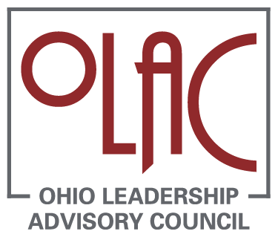

Note-Taking Organizer for Video

Leadership Coaching: Enhancing a Principal’s Instructional Leadership Skills

View each section of the video. Follow the instructions of the narrator to identify discussion points that address the general practice areas and the elements within each area.

Inclusive Instructional and Organizational Leadership
Promote system-wide learning
Prioritize the improvement of teaching and learning
Build capacity through support and accountability
Sustain an open and collaborative culture

Capacity Building Through Professional Capital
Human Capital--quality and capabilities of educational staff
Social Capital--quality and impact of interactions
Decisional Capital--capacity and expertise for making decisions

Inclusive Instructional Practices
Planning of Instruction
Delivery of Instruction
Assessment of Instruction

Wrap Up Discussion

